**Transferring data with AzCopy in Windows**

**Introduction:**

The Engineering team of Fabrikam is impressed by the throughput that they got while using Azure SQL Datawarehouse with Data Factory. The team is now working with Azure Blob storage using AZCopy commands. They are trying to utilize the power of CLI to upload, download and manage their object data into Azure Blob Storage Account. Their goal is to upload object data from on-premises to Azure Blob storage and download the same from there using AZCopy commands. They are also trying to understand how the data can be copied between different blob storage accounts in Azure. On a successful execution of this, the team is going to get adopted with AZCopy commands to manage the object data in Azure Blobs.

**Prerequisites:**

To perform this demo user must have a valid Azure subscription and some knowledge on

* AzCopy
* Storage account
* Containers

**Demo:**

Log-in to Azure portal with your account using [www.portal.azure.com](http://www.portal.azure.com). In Azure portal click on **Create a new resource>Storage>Storage account**.

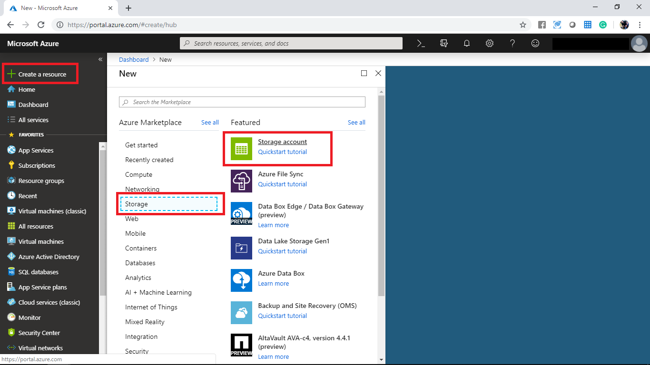

In the create storage account panel create a Storage account with following settings.

* Subscription: Select a valid subscription
* Resource group: Create a new resource group **fabrikamstorage**
* Storage account name: fabrikamstr
* Location: Select a valid location
* Performance: Standard
* Account kind: Storage V2
* Replication: RA-GRS
* Access tier: Hot

After configuring all the above settings click on Review + Create.

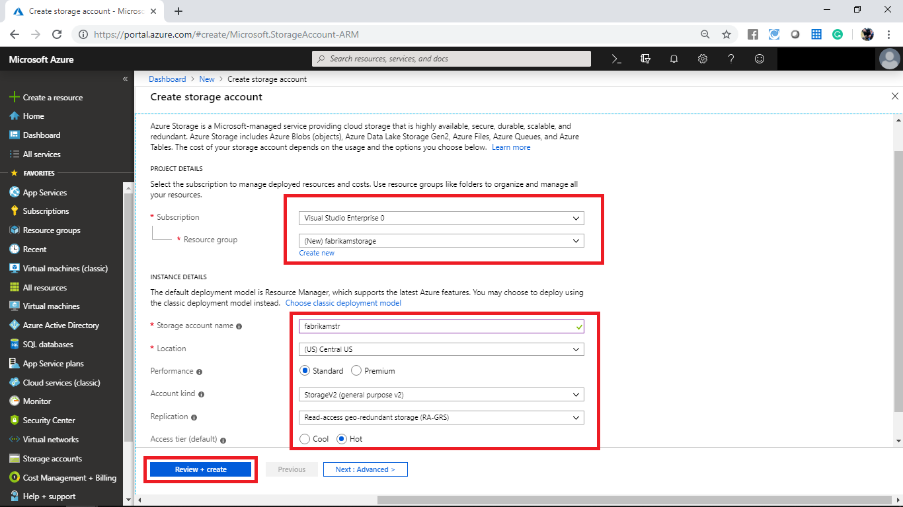

Once your validation gets paused click on create.

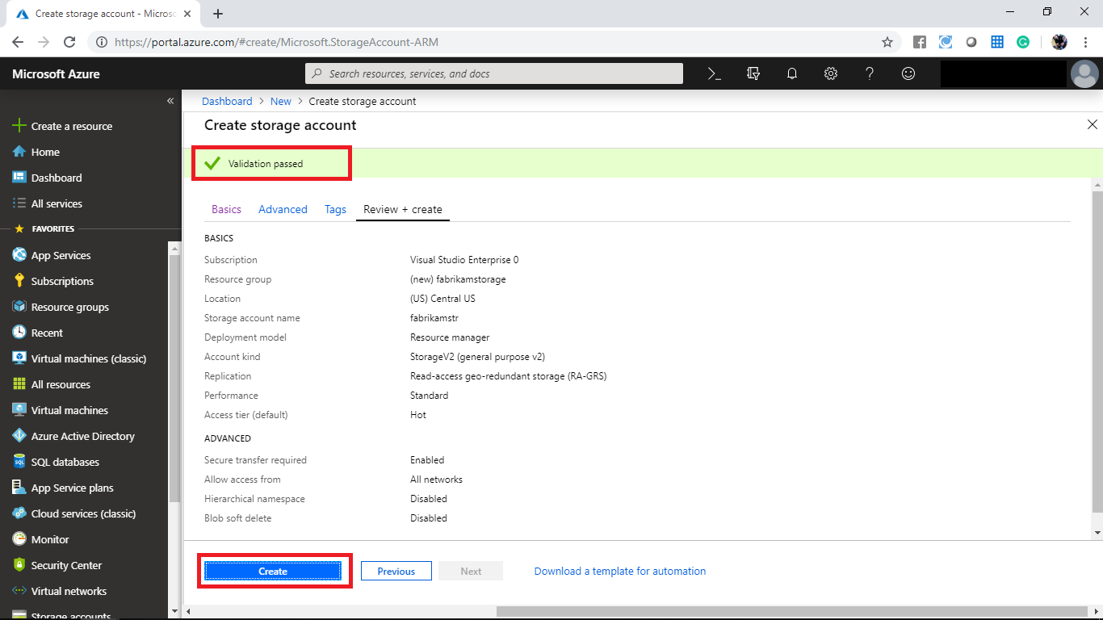

Wait until the deployment gets succeed. After the deployment get completed navigate to the created resource group. In the created storage account display the access key panel and take a note on access key you will use that.

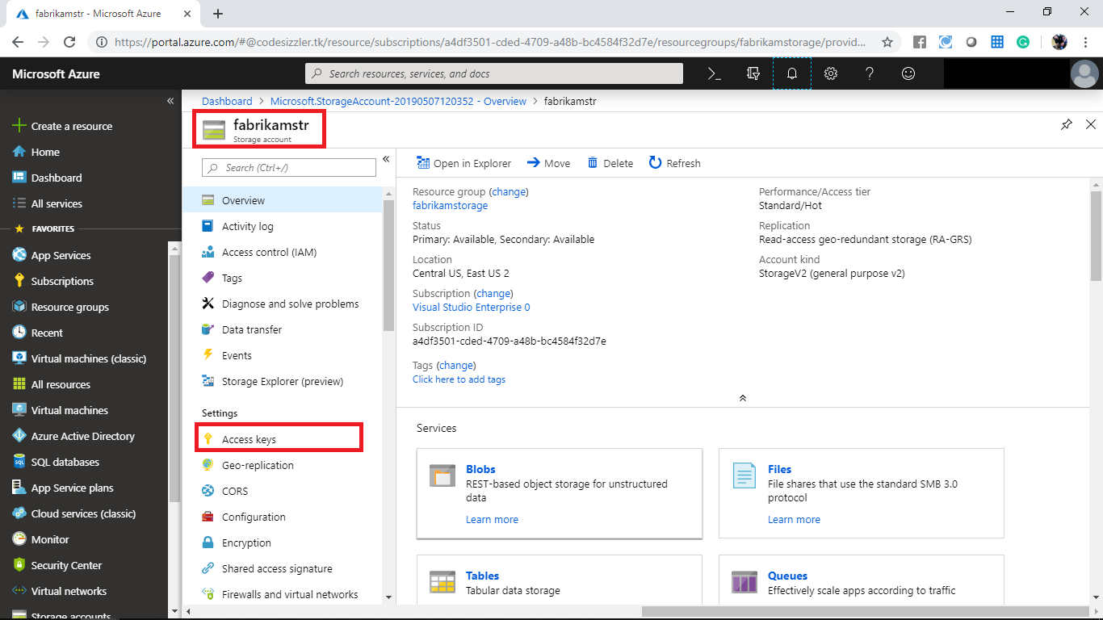

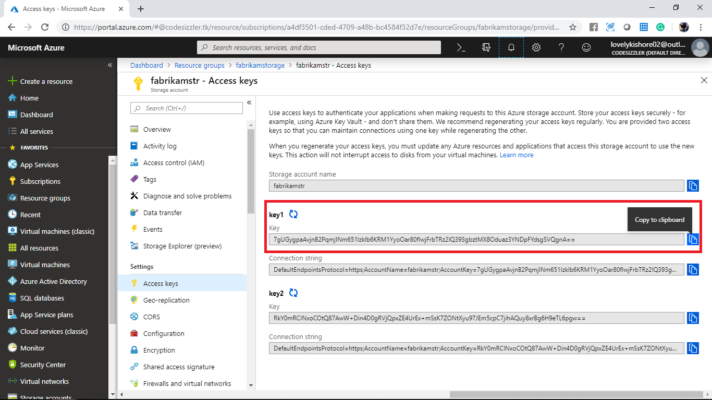

In the overview panel of the storage account click on blob storage.

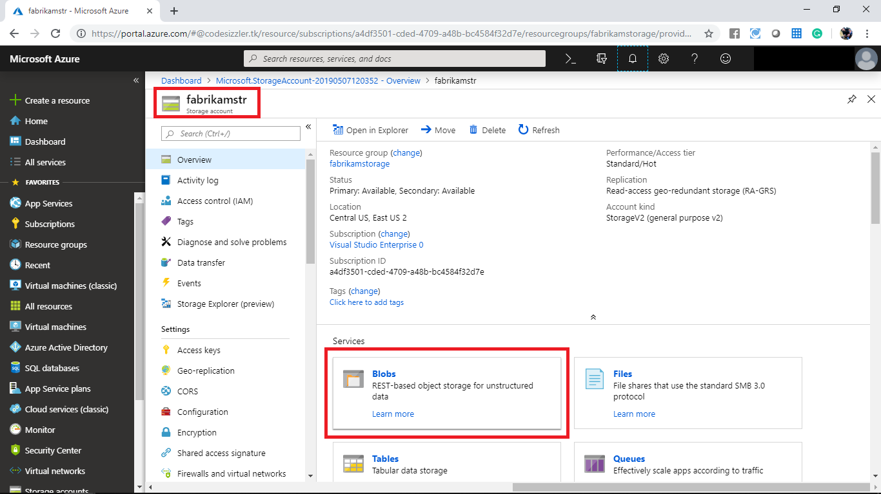

In the blob storage panel click on +container and add a container with following configurations.

* Name: fabrikamcontainer
* Public access level: Container

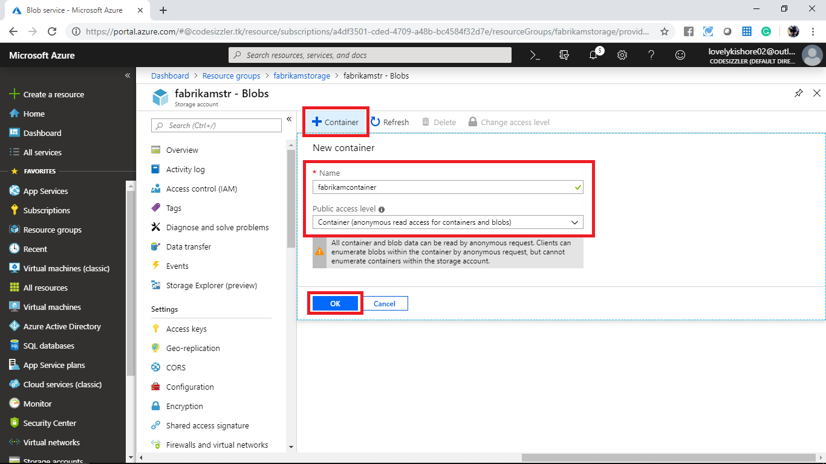

Navigate to the created container and click on upload to upload a sample file.

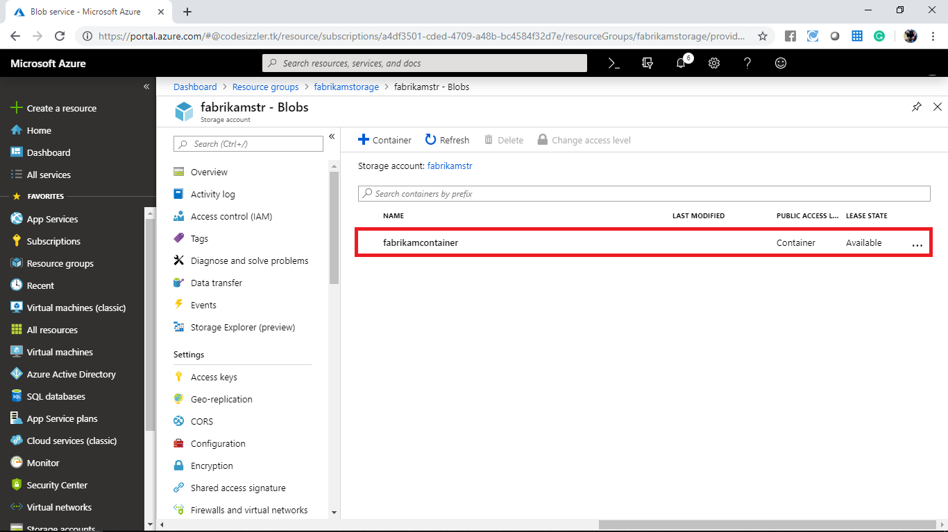

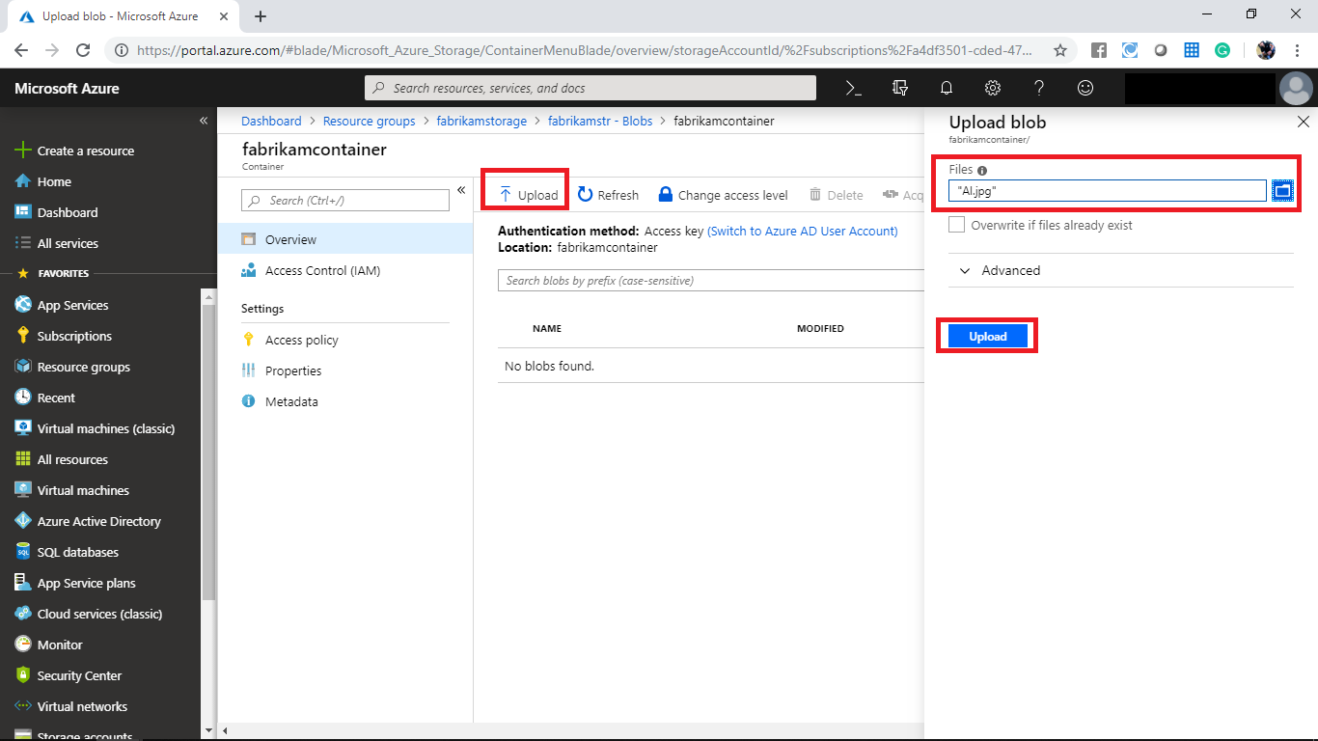

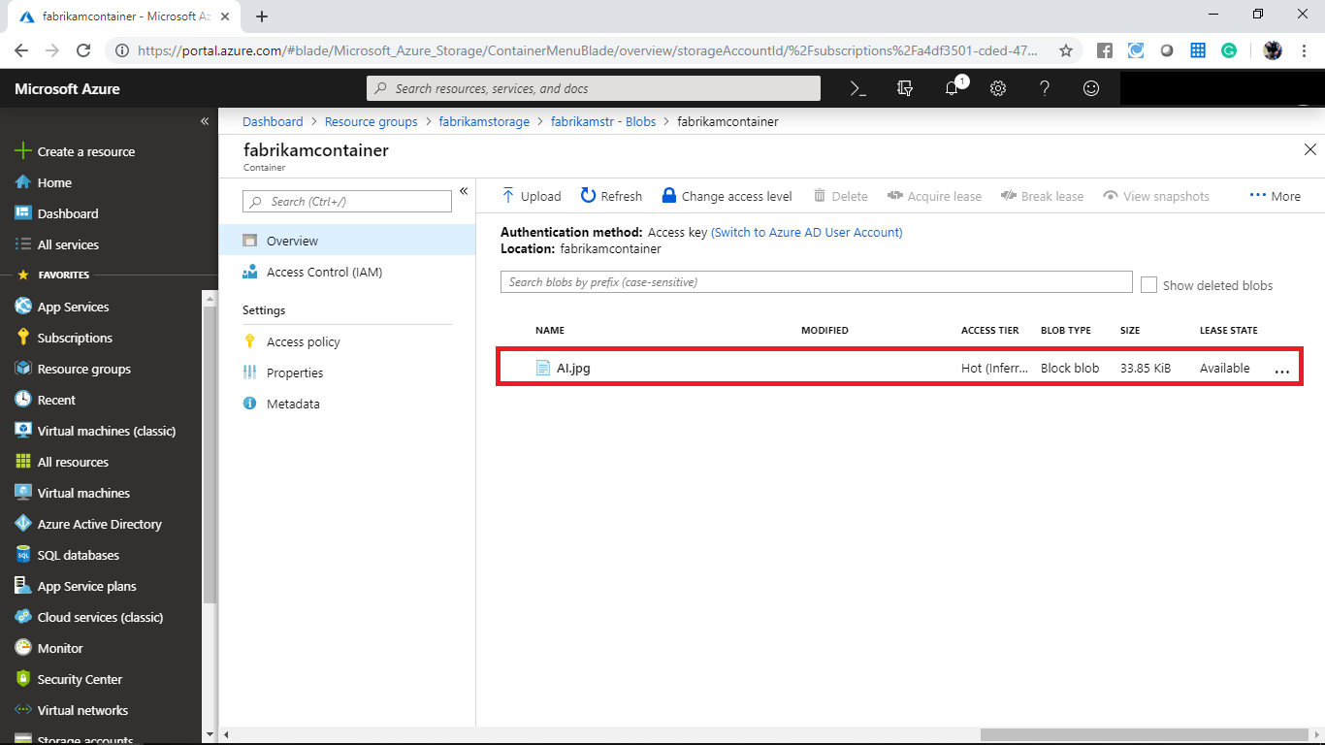

After uploading the sample file navigate to <https://aka.ms/downloadazcopy> and download the AzCopy on your machine. Install the AzCopy after the download completes.

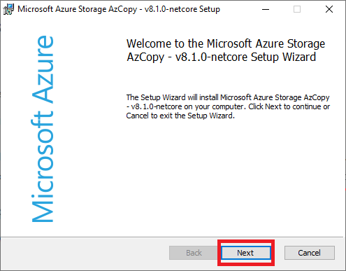

Navigate to the path where the AzCopy is downloaded and copy the path.

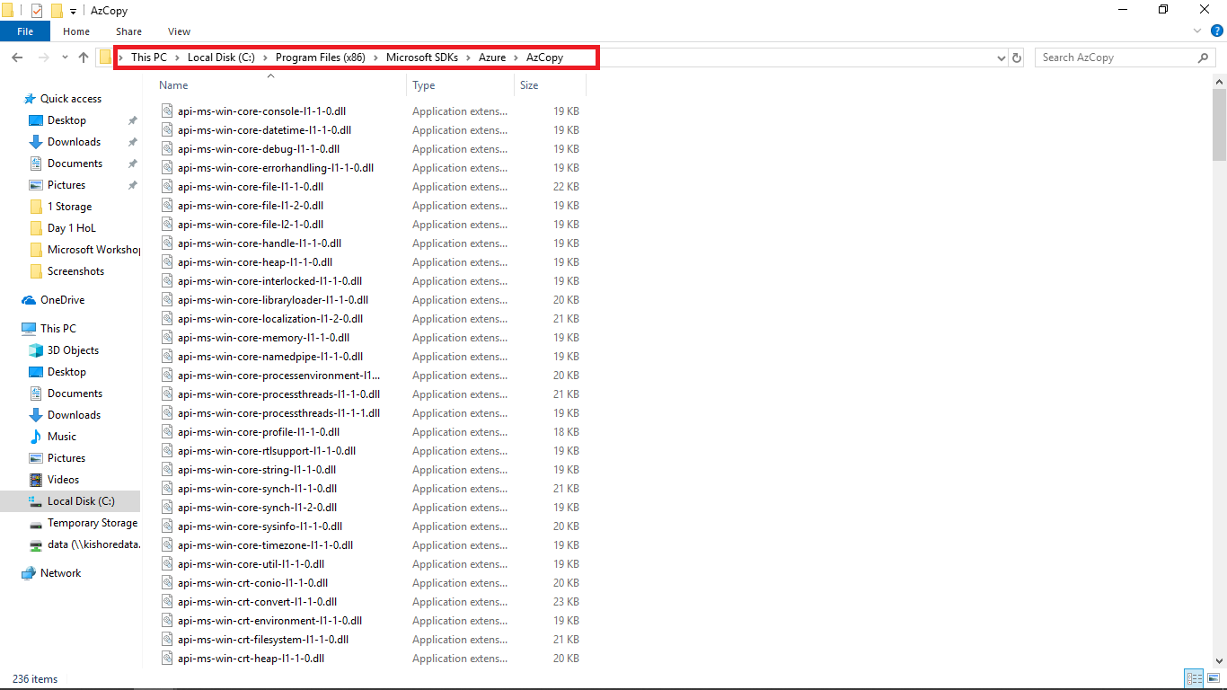

Open the command prompt and change the directory to the copied path.

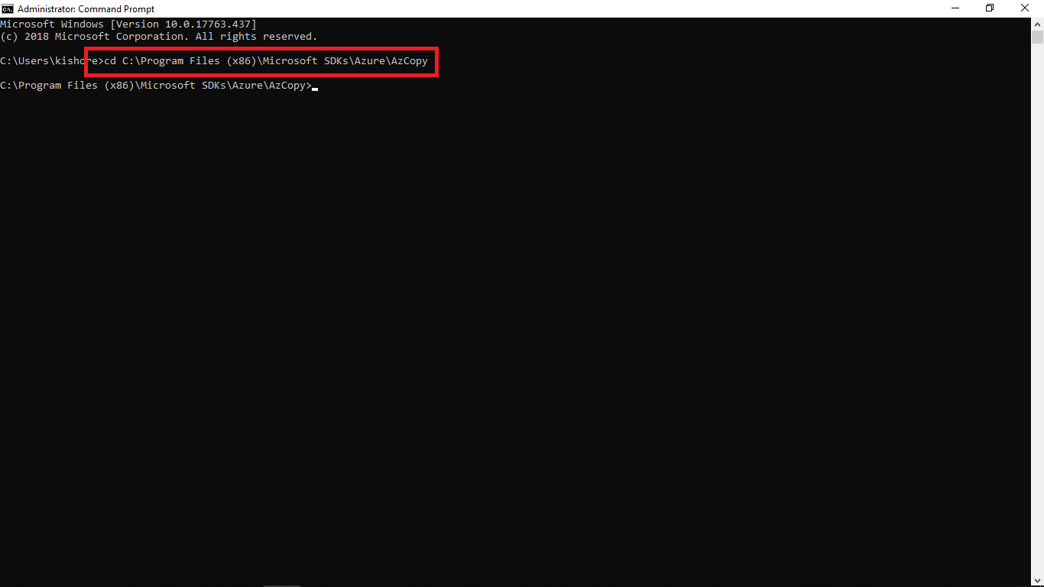

After changing the directory run the following command to transfer the file from your blob storage to your local machine. Replace the path where you need transfer the file.

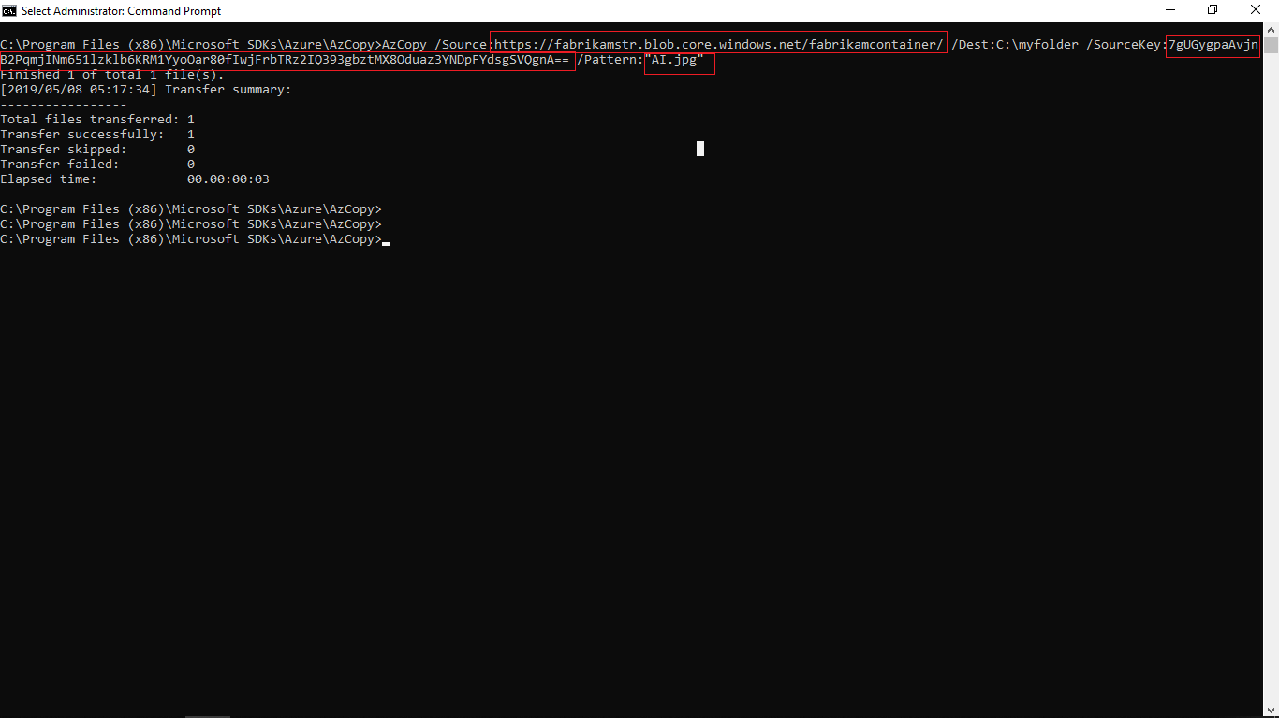

AzCopy /Source:https://fabrikamstr.blob.core.windows.net/fabrikamcontainer/

/Dest:C:\myfolder /SourceKey:7gUGygpaAvjnB2PqmjINm651lzklb6KRM1YyoOar80fIwjFrbTRz2IQ393gbztMX8Oduaz3YNDpFYdsgSVQgnA== /Pattern:"AI.jpg"

Navigate to the path and check that the file is transferred or not.

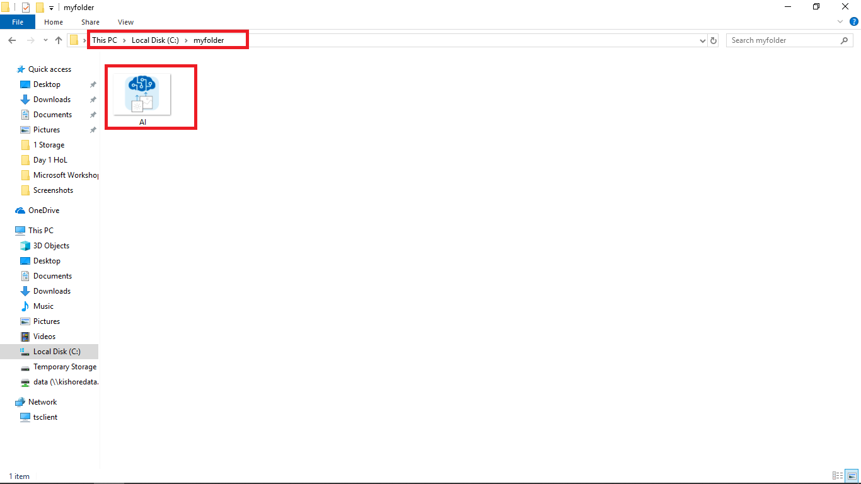

Navigate to the **fabrikamcontainer** and click on upload. When it prompts select multiple files to upload and click on upload.

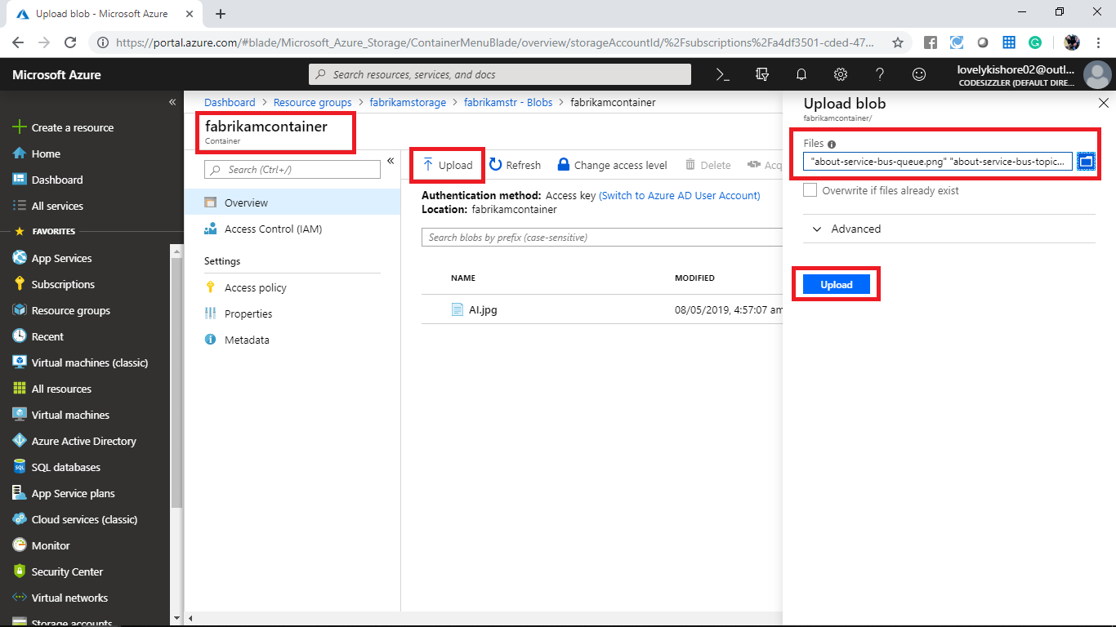

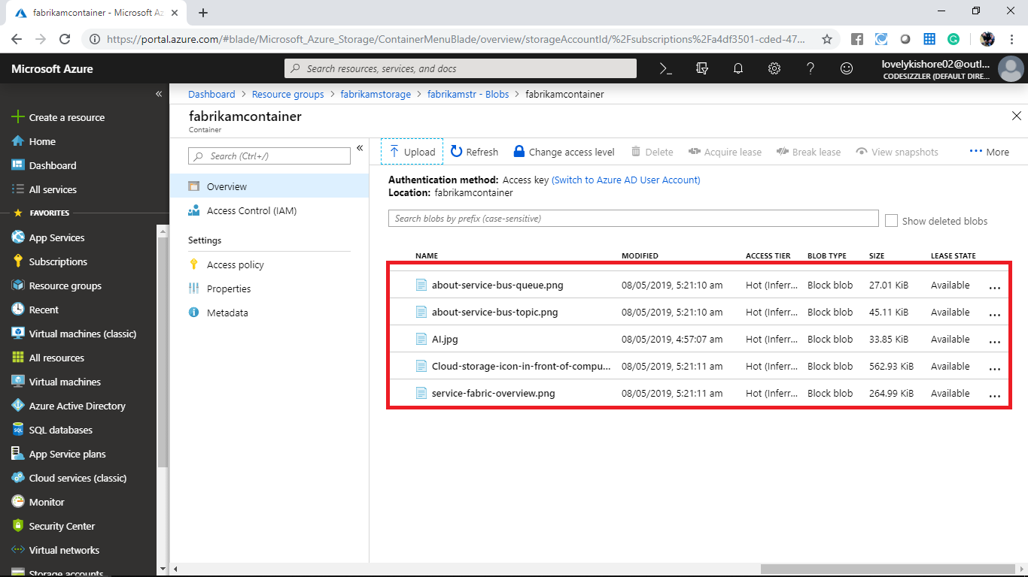

Navigate to command prompt and run the following command to transfer the multiple files from blob storage to your machine.

AzCopy /Source:https://fabrikamstr.blob.core.windows.net/fabrikamcontainer/ /Dest:C:\myfolder /SourceKey:7gUGygpaAvjnB2PqmjINm651lzklb6KRM1YyoOar80fIwjFrbTRz2IQ393gbztMX8Oduaz3YNDpFYdsgSVQgnA== /S

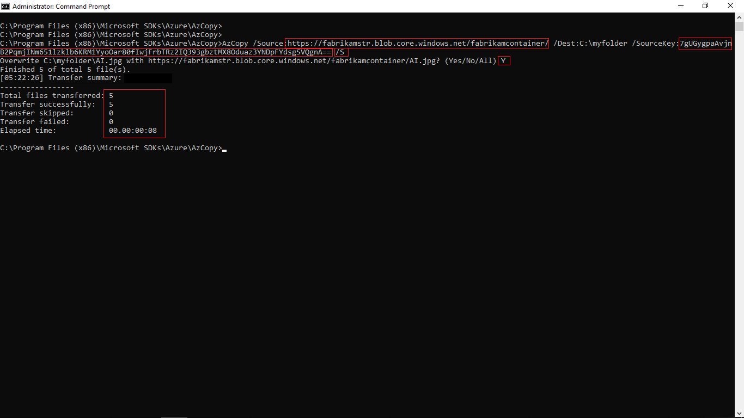

Check that the file were transferred or not.

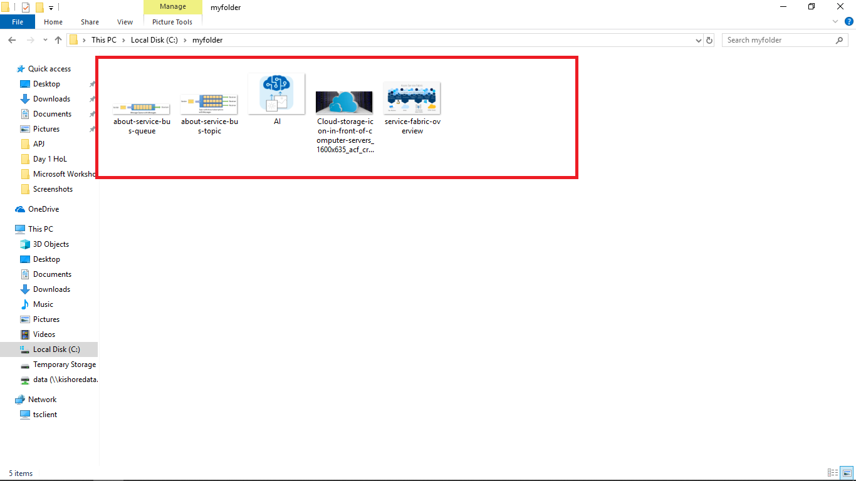

Navigate to the blob storage and delete all the files.

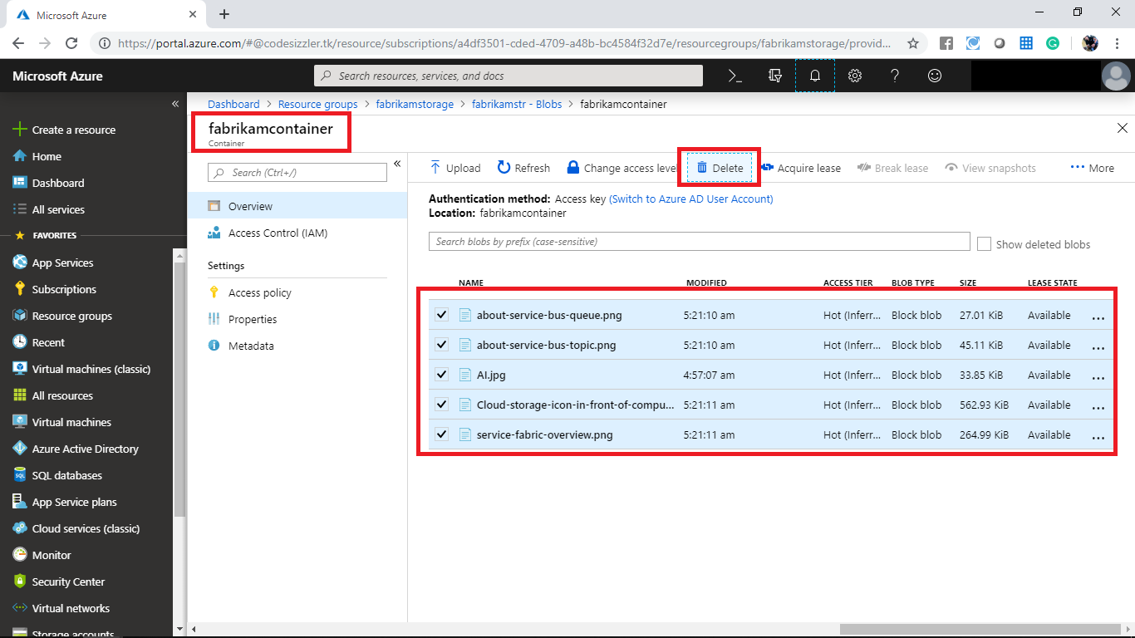

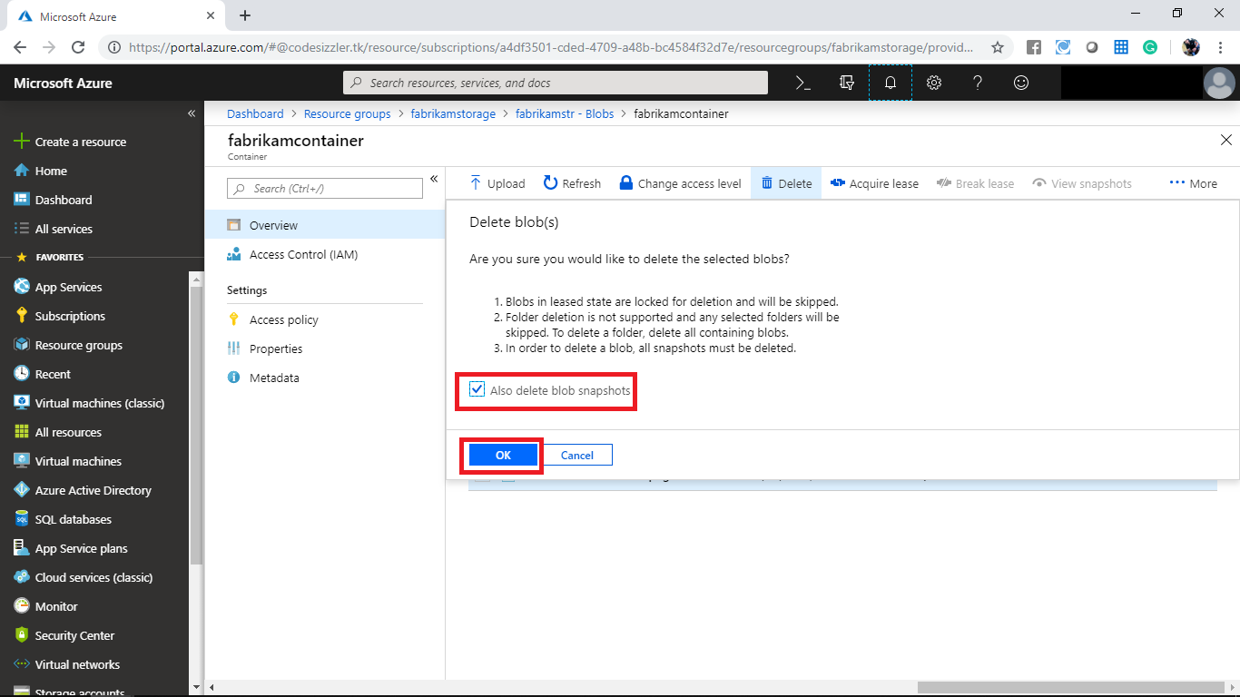

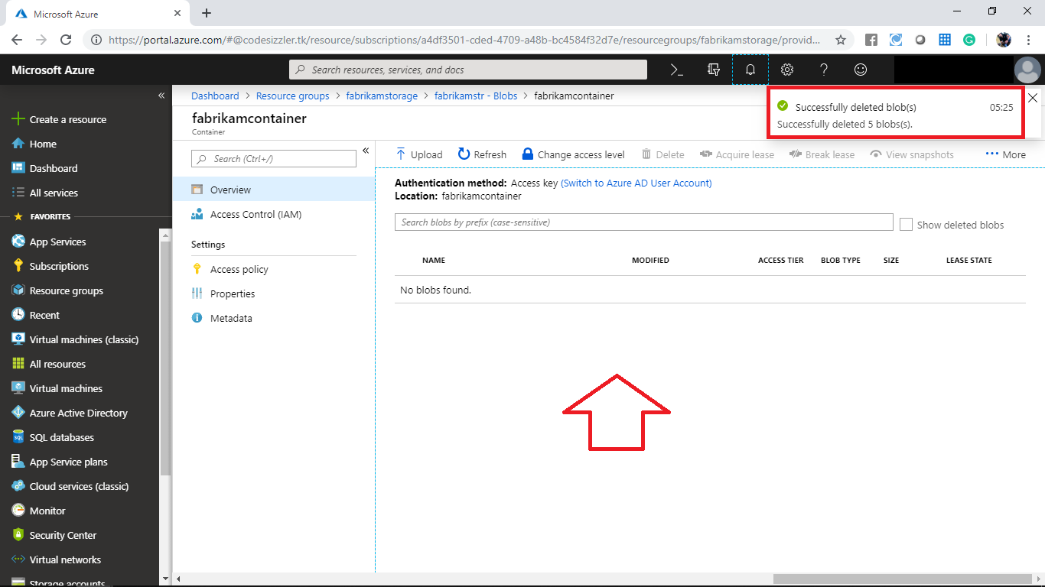

Open the command prompt and run the following command to transfer a single file from local machine to blob storage.

AzCopy /Source:C:\myfolder /Dest:https://fabrikamstr.blob.core.windows.net/fabrikamcontainer/ /DestKey:7gUGygpaAvjnB2PqmjINm651lzklb6KRM1YyoOar80fIwjFrbTRz2IQ393gbztMX8Oduaz3YNDpFYdsgSVQgnA== /Pattern:"AI.jpg"

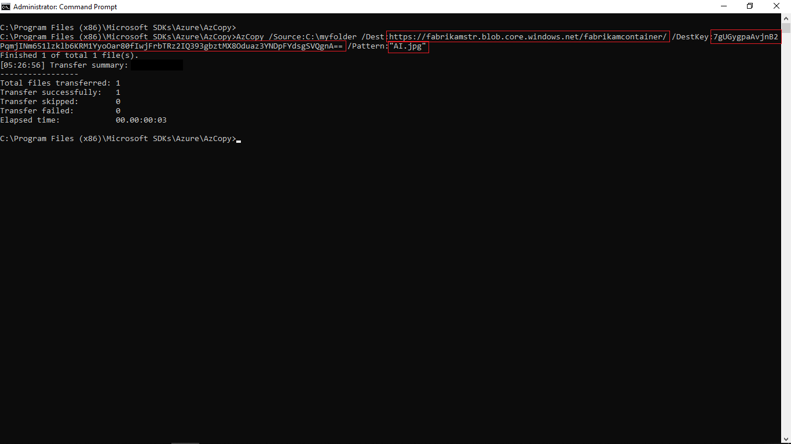

Navigate to the blob storage and check that the files were transferred or not.

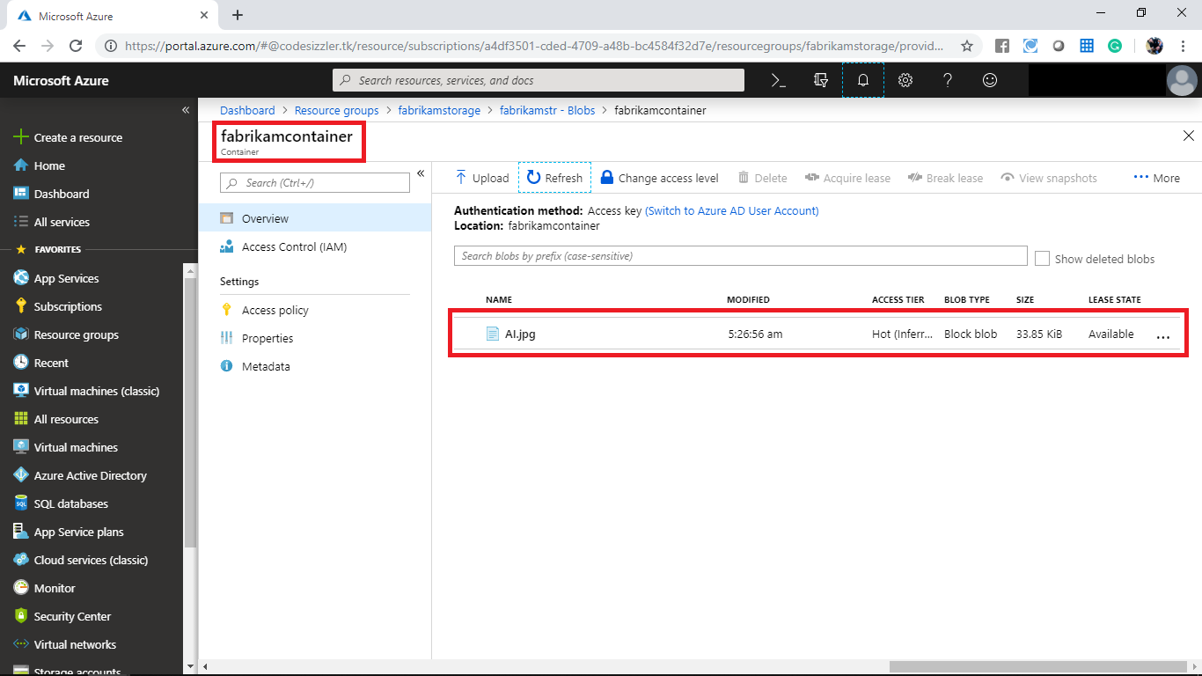

Open the command prompt and run the following command to copy the file from local machine to the blob storage within a virtual folder.

AzCopy /Source:C:\myfolder /Dest:https://fabrikamstr.blob.core.windows.net/fabrikamcontainer/vd /DestKey:7gUGygpaAvjnB2PqmjINm651lzklb6KRM1YyoOar80fIwjFrbTRz2IQ393gbztMX8Oduaz3YNDpFYdsgSVQgnA== /Pattern:"AI.jpg"

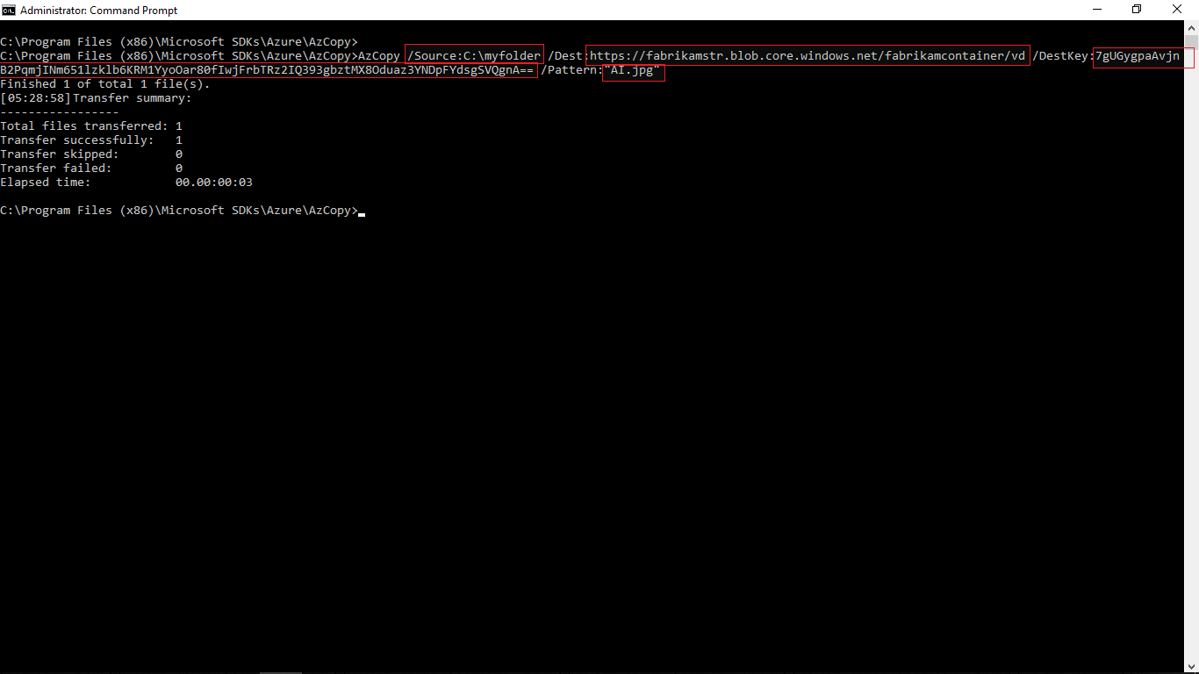

Navigate to the blob storage and monitor that the file has been transferred to the virtual folder or not.

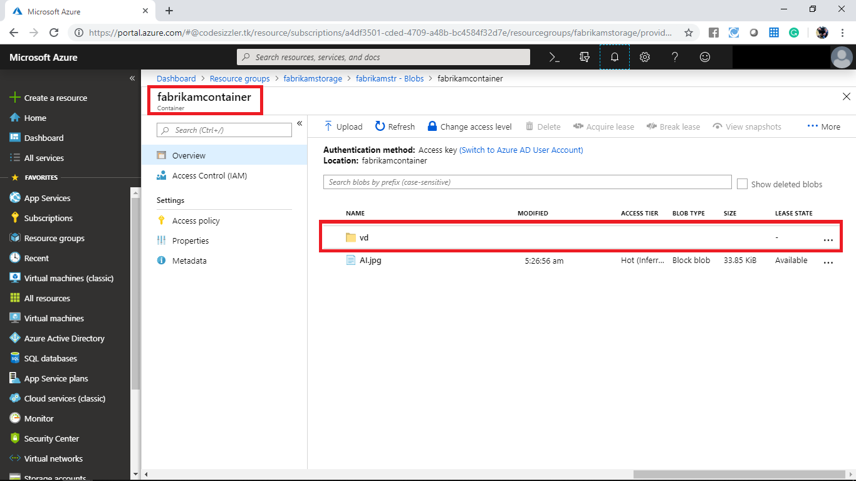

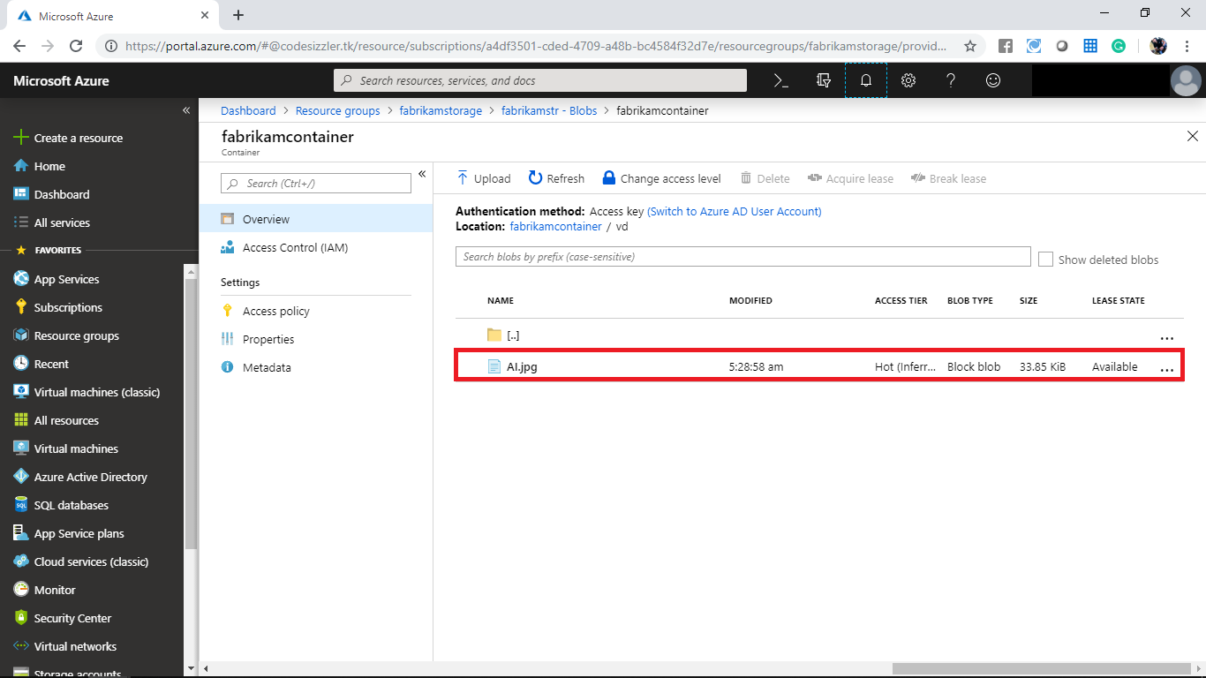

Open the command prompt and run the following command to transfer multiple files from local machine to blob storage within a virtual folder.

AzCopy /Source:C:\myfolder /Dest:https://fabrikamstr.blob.core.windows.net/fabrikamcontainer/vd /DestKey:7gUGygpaAvjnB2PqmjINm651lzklb6KRM1YyoOar80fIwjFrbTRz2IQ393gbztMX8Oduaz3YNDpFYdsgSVQgnA== /S

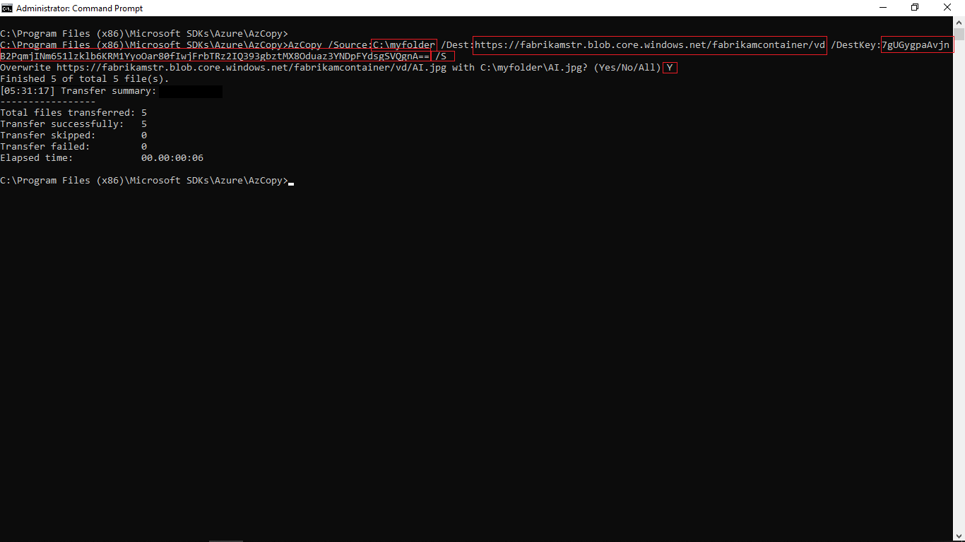

After running the command navigate to the blob storage and note that the files are transferred to the virtual folder or not.

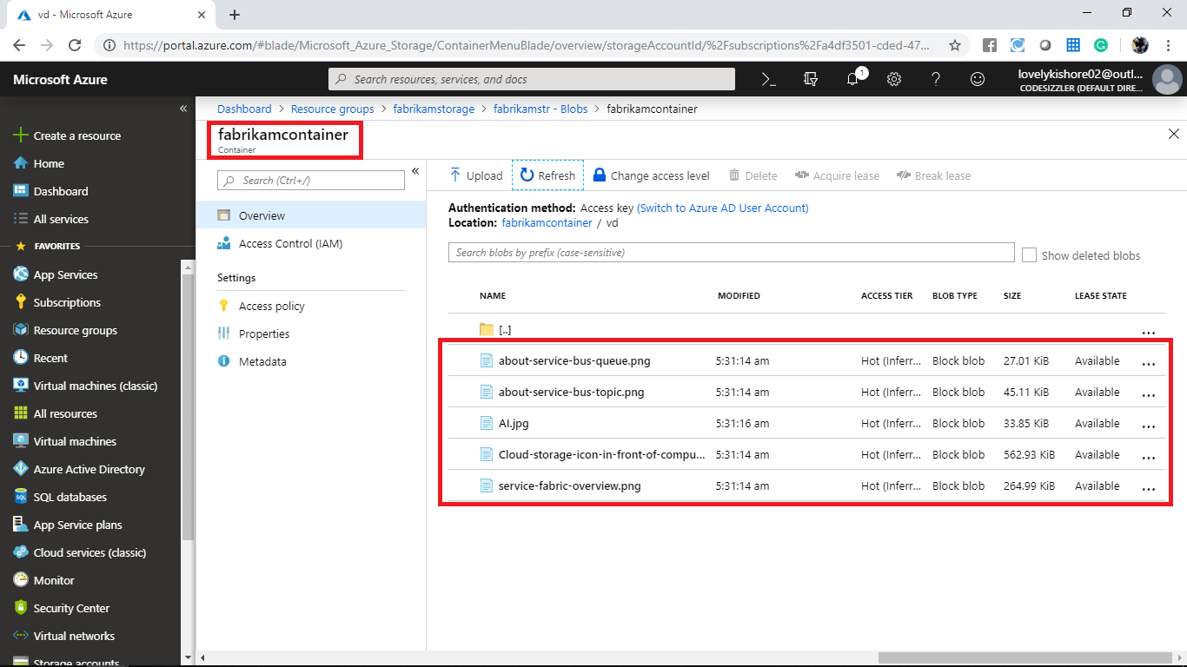

Navigate to the blob overview page and add another container with following configurations.

* Name: fabrikamnewcontainer
* Public access resource: Container

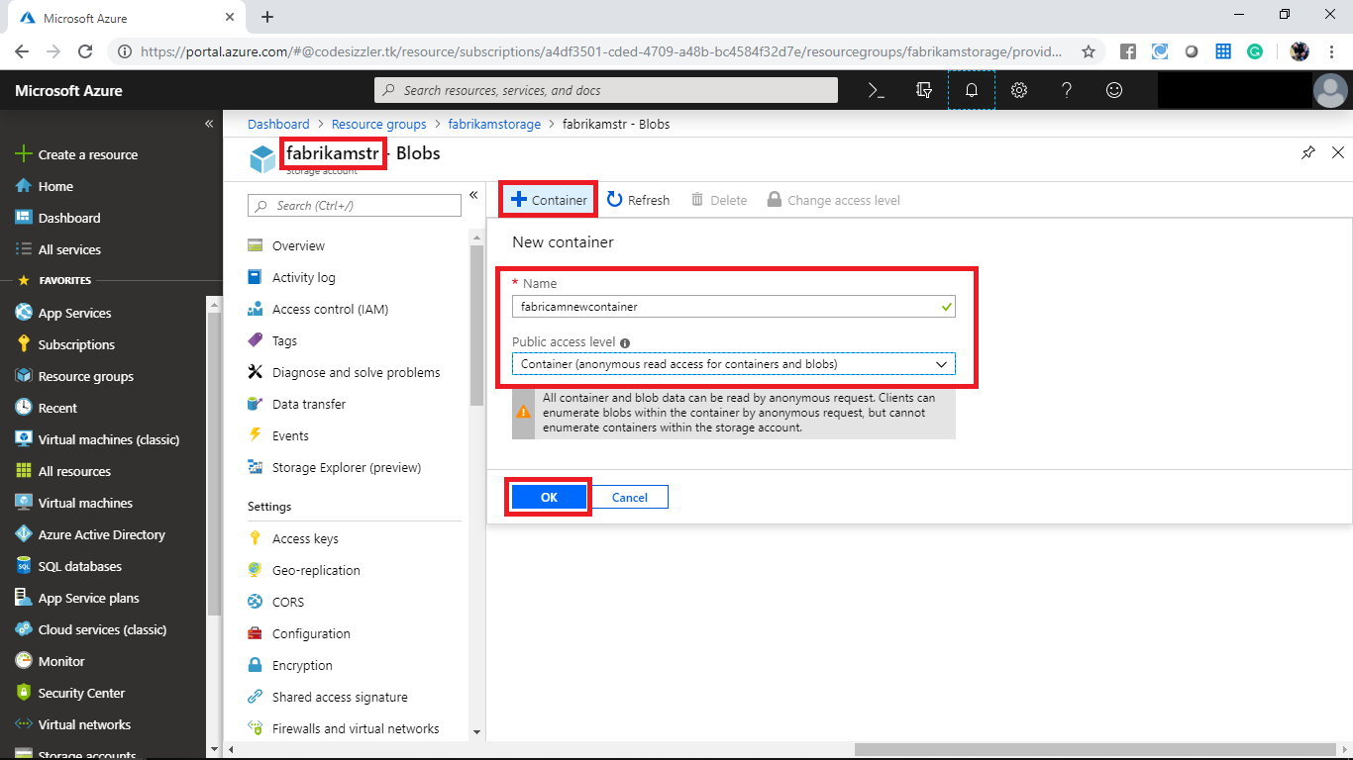

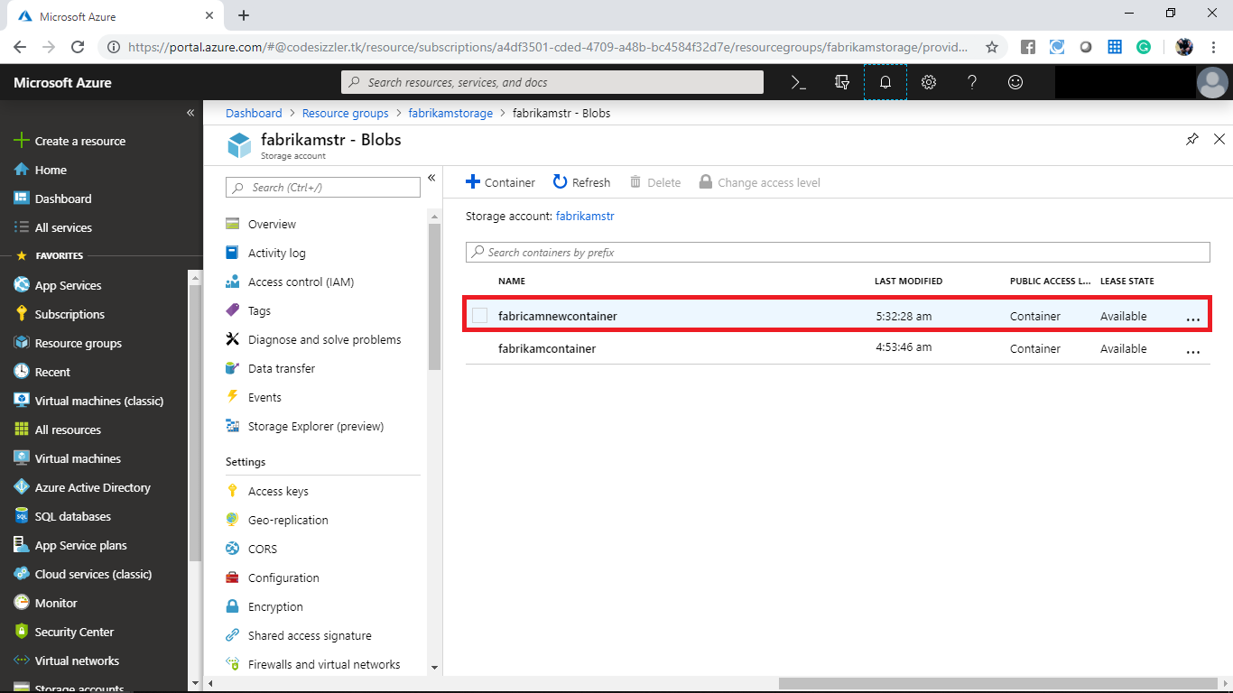

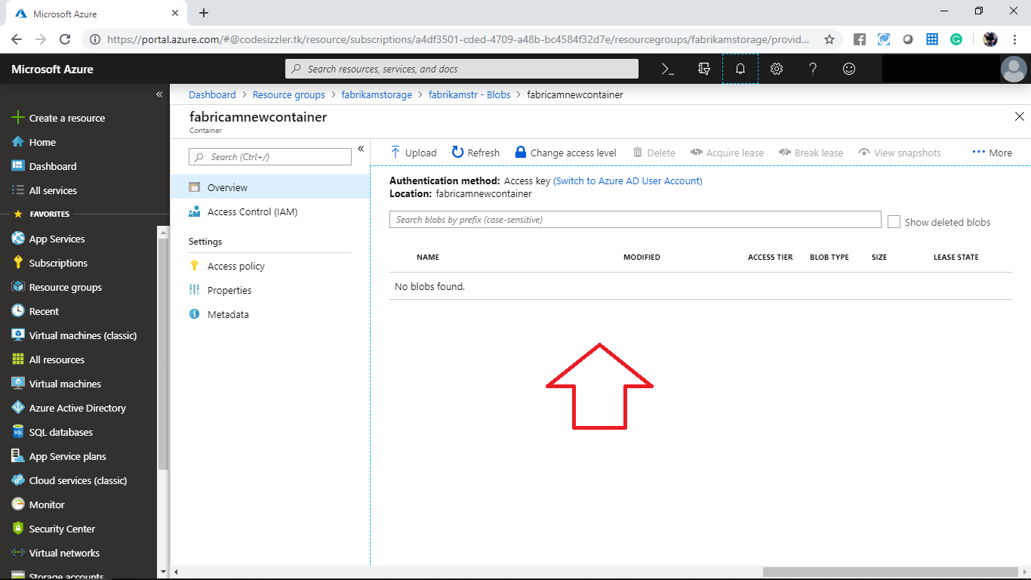

Open the command prompt and run the following command to transfer the files from container to container.

AzCopy /Source:https://fabrikamstr.blob.core.windows.net/fabrikamcontainer/vd /Dest:https://fabrikamstr.blob.core.windows.net/fabrikamnewcontainer /SourceKey:7gUGygpaAvjnB2PqmjINm651lzklb6KRM1YyoOar80fIwjFrbTRz2IQ393gbztMX8Oduaz3YNDpFYdsgSVQgnA== /DestKey:7gUGygpaAvjnB2PqmjINm651lzklb6KRM1YyoOar80fIwjFrbTRz2IQ393gbztMX8Oduaz3YNDpFYdsgSVQgnA== /Pattern:"AI.jpg"

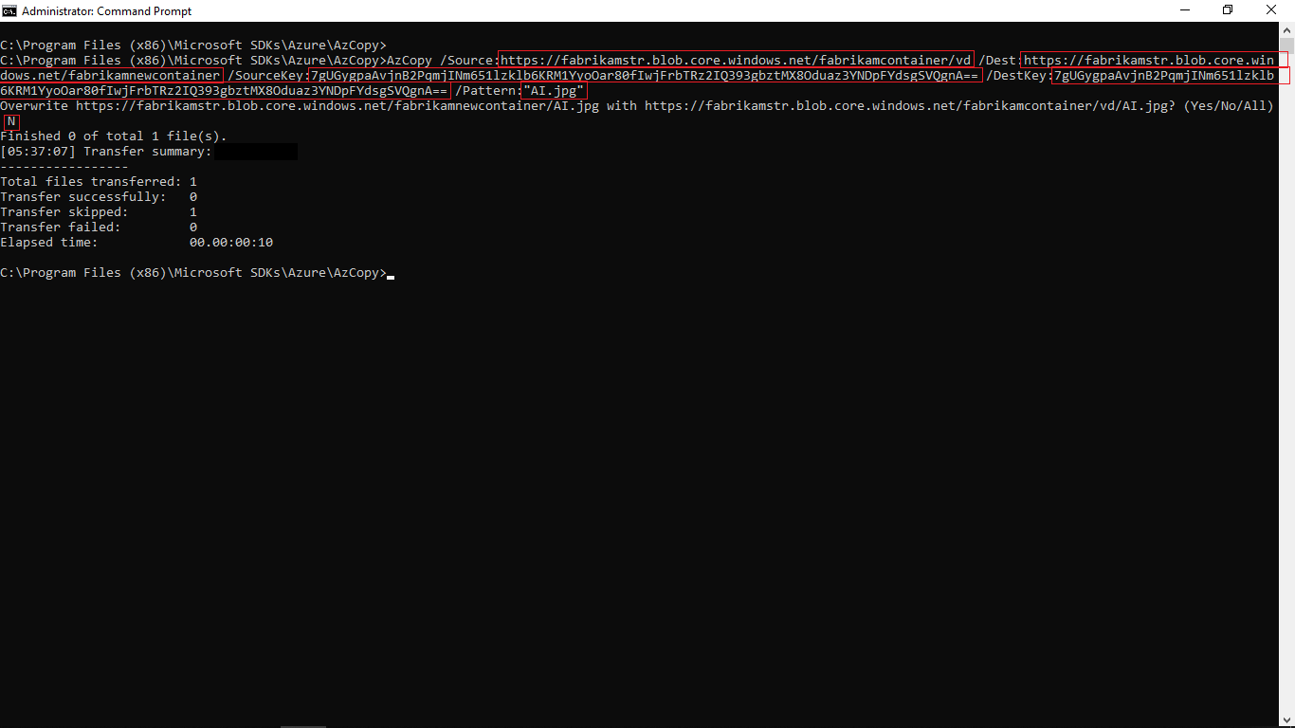

After running the command navigate to the newly created container and note that the file was transferred or not.

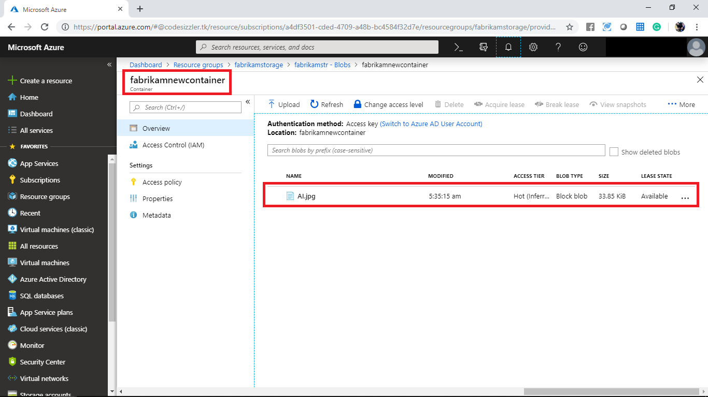

In Azure portal click on **Create a new resource>Storage>Storage account**. User the search list to create a storage account.

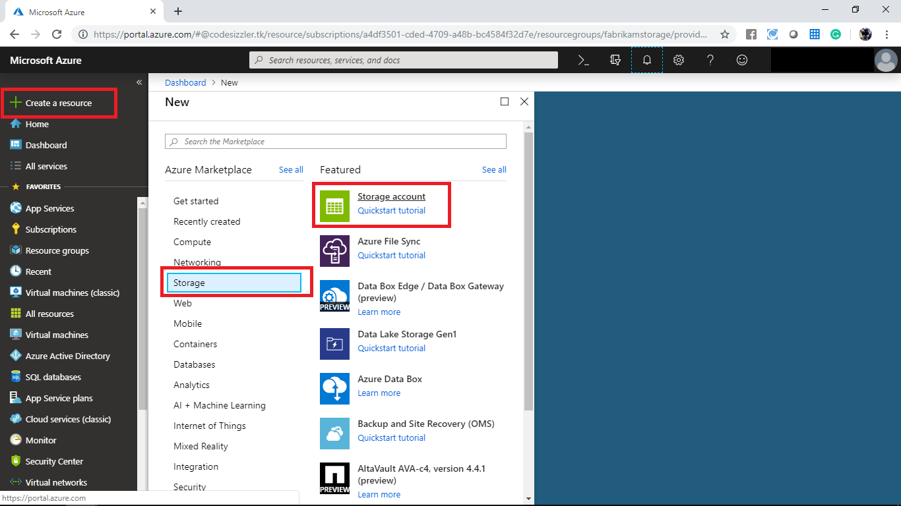

Create a Storage account with following configurations

* Subscription: Select a valid one
* Resource group: fabrikamstorage
* Storage account name: fabrikamnewstorage
* Location: Select a valid location
* Performance: Standard
* Account kind: Storage V2
* Replication: RA-GRS
* Access tier: Hot

After configuring all the above settings click on Review + Create.

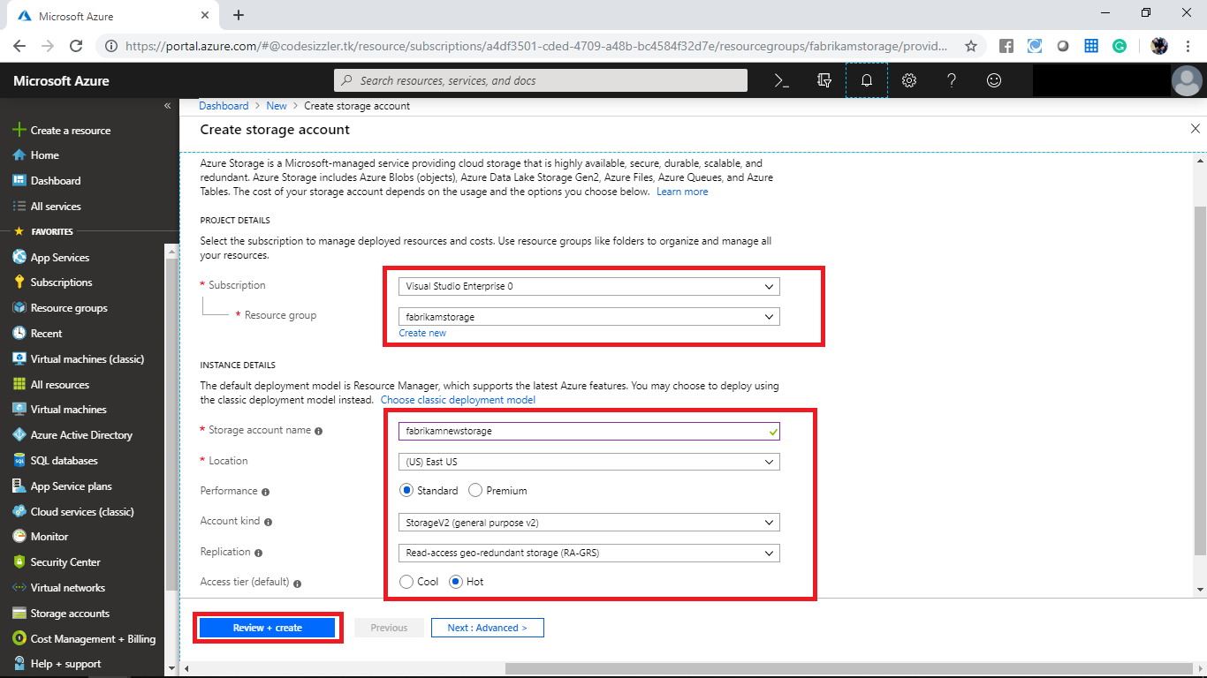

Once your validation gets paused click on create.

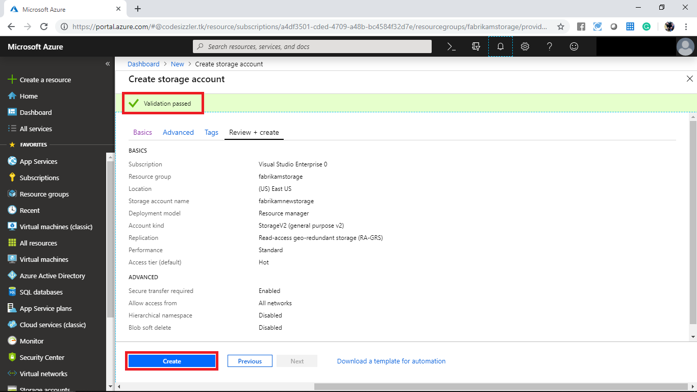

Wait until the deployment gets succeed. After the deployment get completed navigate to the created resource group. In the created storage account display the access key panel and take a note on access key you will use that in the next step.

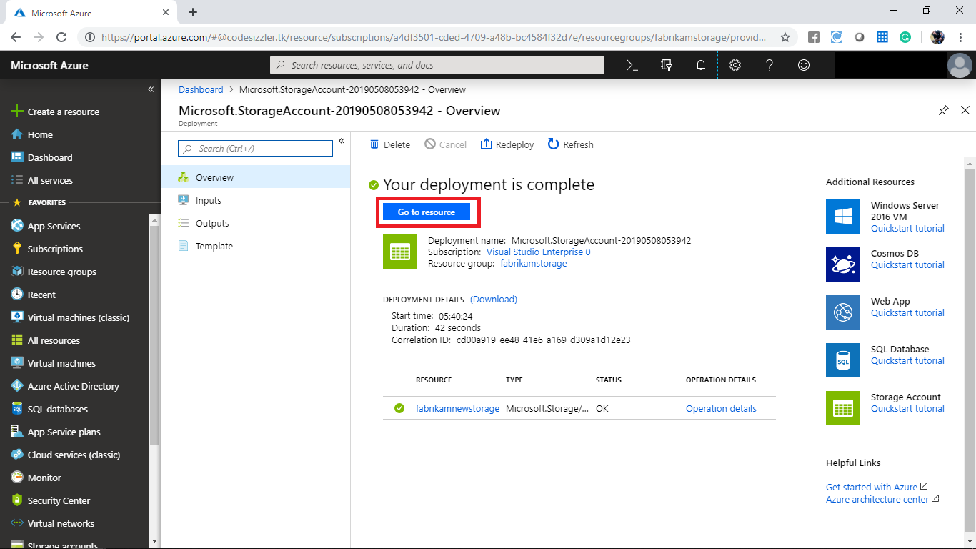

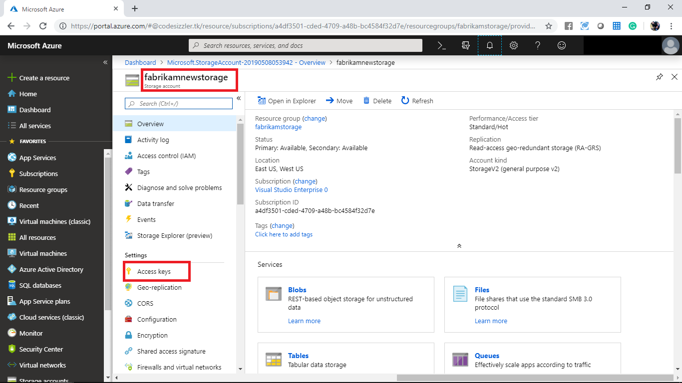

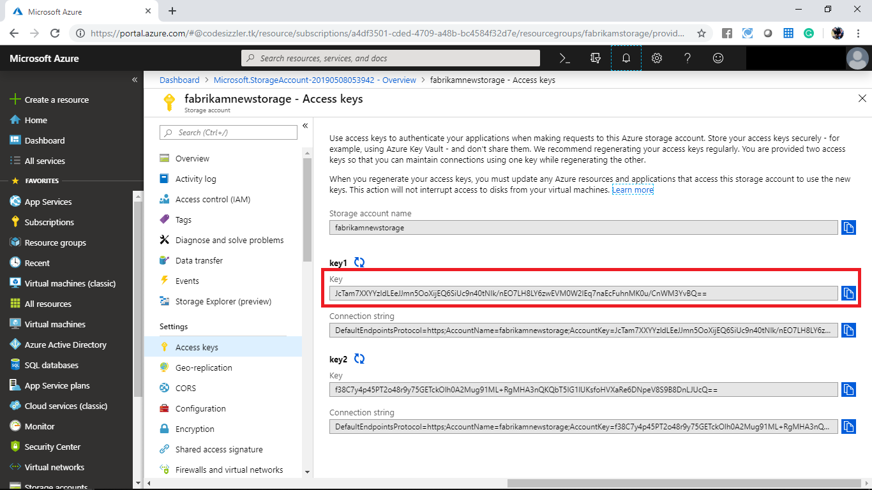

Open the command prompt and run the following command to transfer the files from one blob storage to another blob storage. Replace the respective values with your values.

AzCopy /Source:https://fabrikamstr.blob.core.windows.net/fabrikamcontainer/vd /Dest:https://fabrikamnewstorage.blob.core.windows.net/newcontainer /SourceKey:7gUGygpaAvjnB2PqmjINm651lzklb6KRM1YyoOar80fIwjFrbTRz2IQ393gbztMX8Oduaz3YNDpFYdsgSVQgnA== /DestKey:JcTam7XXYYzldLEeJJmn5OoXijEQ6SiUc9n40tNIk/nEO7LH8LY6zwEVM0W2lEq7naEcFuhnMK0u/CnWM3YvBQ== /S

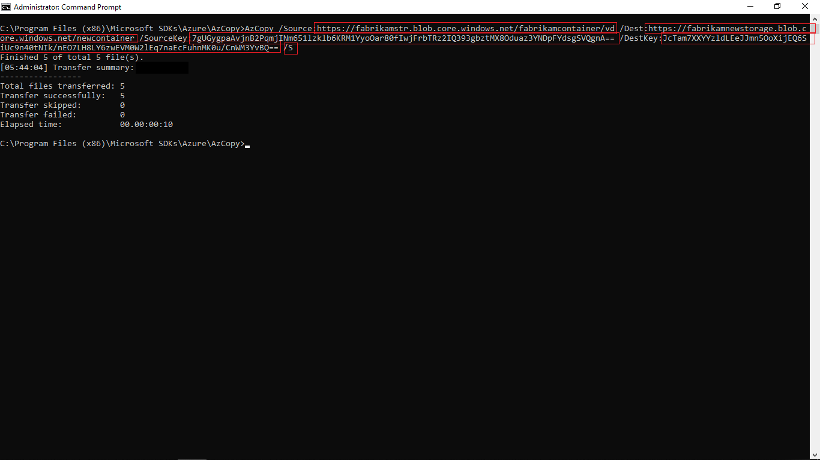

After running the command navigate to the newly created blob storage account and note that the files were transferred or not.

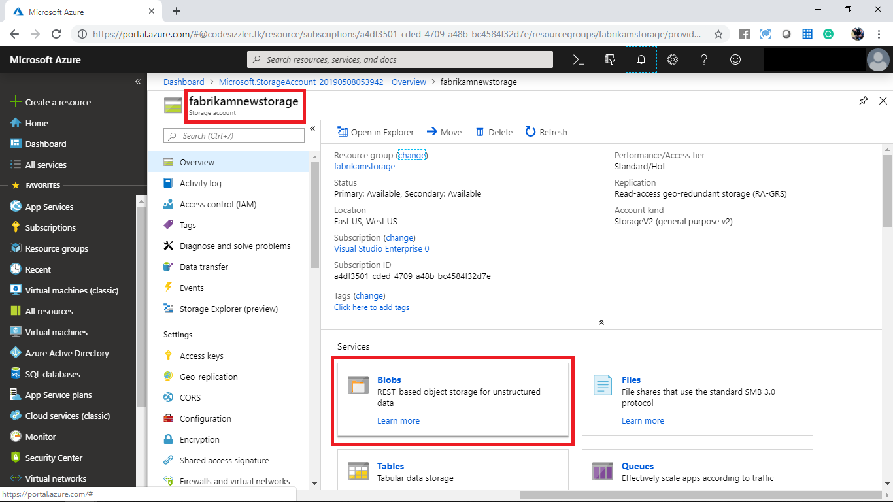

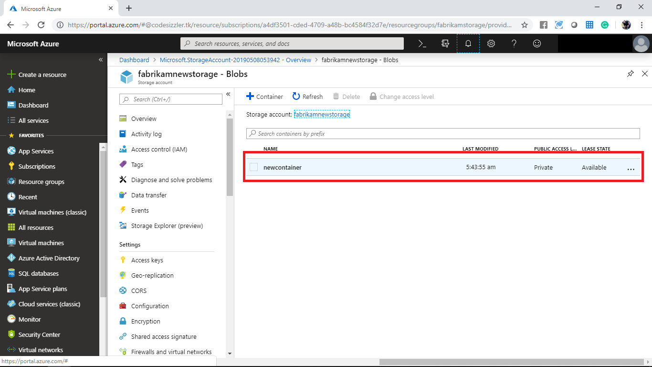

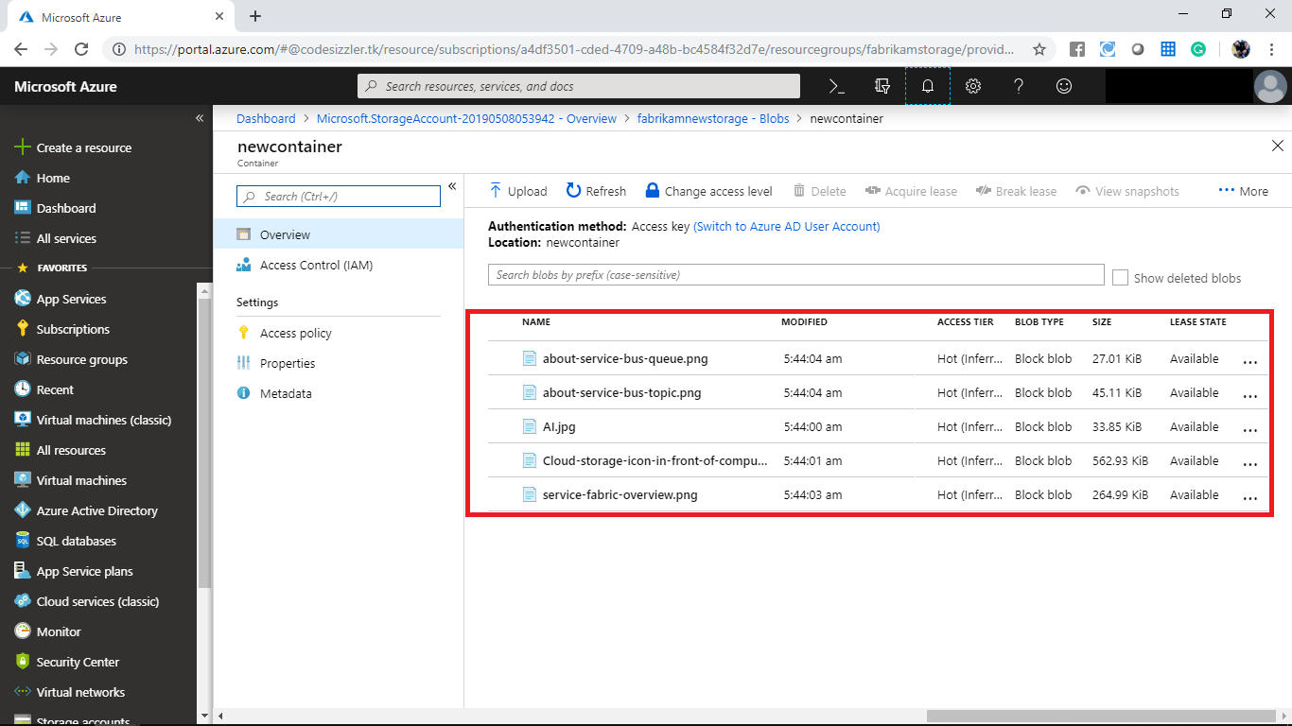

**Summary:**

AZCopy command line environment has well suited for the Fabrikam team. The team felt that management of Azure Blob resources by using AZCopy commands was quite easy and adoptable. With the power of AZCopy, the team will be able to upload and download and even manage the object data using AZCopy commands.